THREADS 2026 MEDIA CONSENT FORM

For permitting the Creator’s enrollment and participation in its program(s) and for other good and valuable consideration, the receipt and sufficiency of which is acknowledged, the undersigned (“I” or “me”) grants to George Brown Polytechnic and its delegates (the “Polytechnic”) the right to reproduce and republish in print and/or digital format and to take and make photographs, sound recordings, and/or video recordings of the Creator, their voice, likeness, and property including any works created by the Creator (collectively, the “Recordings”) for use in connection with the activities of the Polytechnic including teaching, and for promoting, publicizing, reporting or explaining the Polytechnic or its activities (the “Purpose”). I acknowledge that as between the Creator/me and the Polytechnic, the Polytechnic owns all copyright in the Recordings, and waives any and all moral and personality rights the Creator may have in the Recordings. I confirm that the Polytechnic can do anything with the Recordings for the Purpose, including use, reproduce, exhibit, display, distribute, edit, modify, translate and publish the Recordings, without any geographic restriction, in any format without further compensation or notification to the Creator/me. This includes, without limitation, the right to publish the Recording in the Polytechnic newspaper, alumni magazine, and PR/promotional materials such as marketing admission publications, advertisements, fundraising materials, and any other Polytechnic-related publications. I acknowledge that The Polytechnic is not responsible for any unauthorized reproductions of the Recordings made by third parties. I further acknowledge that the Recordings may appear on the Internet or in publications outside of The Polytechnic’s control. I hereby remise, release and forever discharge The Polytechnic from any and all claims, demands and causes of action that I/the Creator had, now have, and may hereafter have in any way related to the Recordings. This Media Consent Form is governed by the laws of Ontario.

Name (please print): Frank Job

Signature: 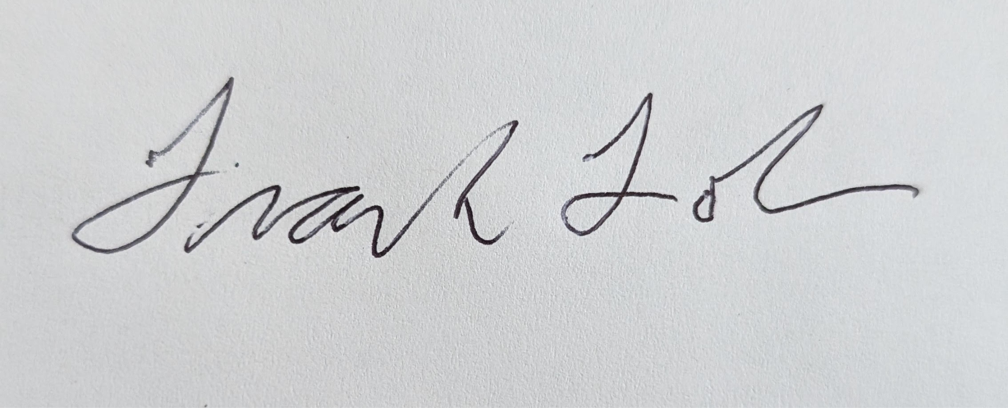

Date Signed: 21/ 04 / 2026 (day/month/year)

